

**SESSION A201**

**STIJ3074 WEB PROGRAMMING**

**PROBLEM SET 3**

**NAMA : MOHAMAD NIZAM BIN MOHD YUSERI**

**NO MATRIK : 263978**

PREPARED FOR : -

**AHMAD HANIS BIN MOHD SHABLI**

INSERT FOOD PAGE

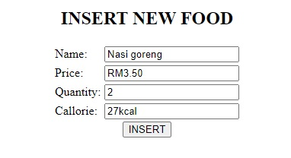

INSERT FOOD HTML SCRIPT

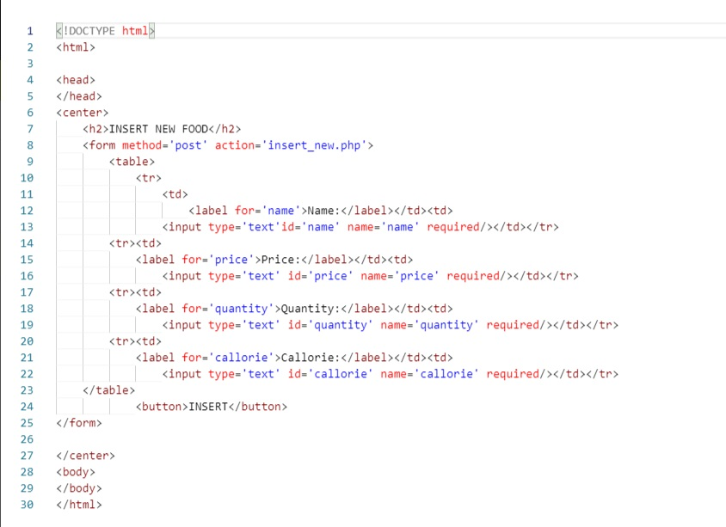

INSERT FOOD PHP SCRIPT

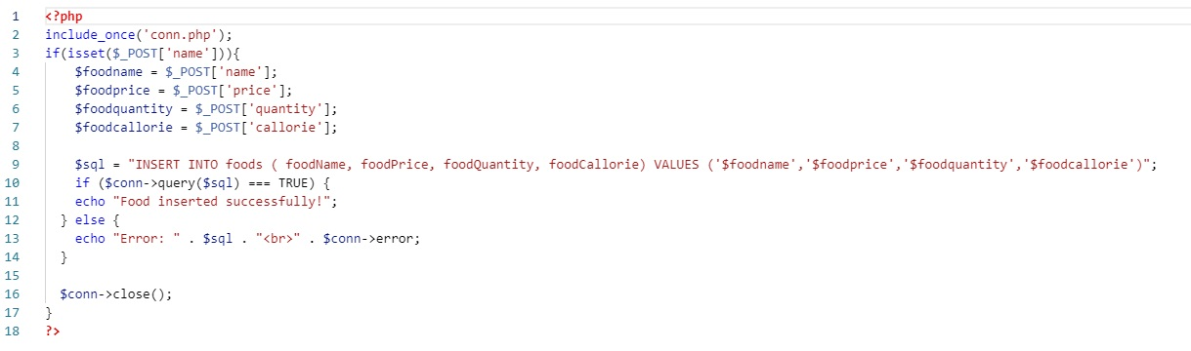

RESULT



Database

